



Sexual Assault and Sexual Harassment

Student Factsheet

Made by the Safer Community Team

**swinburne.edu.au/safercommunity**



# What is sexual assault?

Sexual assault is when a person is forced, coerced, or tricked into sexual acts against their will or without their consent. Consent is when a person freely (without coercion, force, intimidation, or any other means) agrees to an activity.

Sexual assault is a general term used to describe a broad range of unwanted sexual behaviours. Sexual offences are serious crimes in Victoria and governed by the [Crimes Act 1958 (Vic)](https://www.legislation.vic.gov.au/in-force/acts/crimes-act-1958/294). The legal definition for sexual assault is much narrower than the one we have provided, as different sexual offences (e.g., rape) have specific definitions outlined in the Crimes Act 1958.

Examples:

* Unwanted touching, hugging, fondling, or kissing.
* Being made to look at, or pose for, pornographic photos and videos.
* Public exposure.
* Voyeurism (e.g., being watched doing intimate things without permission).
* Incest.
* Rape.

What is sexual harassment?

Sexual harassment is when a person makes an unwelcome sexual advance, or an unwelcome request for sexual favours to another person, and/or engages in any other unwelcome conduct of a sexual nature in relation to another person.

Sexual harassment is unlawful in Australia. In Victoria, you can refer to the [Equal Opportunity Act 2010 (Vic) – Sect 92](http://classic.austlii.edu.au/au/legis/vic/consol_act/eoa2010250/s92.html#:~:text=What%20is%20sexual%20harassment%3F,-(1)%20For%20the&text=in%20circumstances%20in%20which%20a,be%20offended%2C%20humiliated%20or%20intimidated.).

Examples:

* Intrusive questions or statements about a person’s private life.
* Repeatedly asking a person for sex or dates.
* Offensive sexual comments or jokes.
* Sexually suggestive behaviour such as leering or staring.

Terminology

The language we use is important as it can impact how we perceive and interpret information.

The term *sexual harm* is used to refer to a broad range of unwanted sexual behaviours including sexual assault and sexual harassment.

The term *victim survivor* is used to refer to people who have experienced or are experiencing violence, including sexual assault and sexual harassment. The term acknowledges their strengths and resilience in the face of violence.

The term *perpetrator* refers people who choose to use violence, including sexual assault and sexual harassment.

*Offender* is used to describe perpetrators of violence who have been found to have committed a crime.

Some statistics

# According to the [Australian Bureau of Statistics (2016)](https://www.abs.gov.au/statistics/people/crime-and-justice/personal-safety-australia/latest-release#:~:text=This%20release%20presents%20information%20from%20the%20Australian%20Bureau,detailed%20information%20about%20men%27s%20and%20women%27s%20experience%20of%3A), in Australia:

* 17% of women and 4% of men over 18 years old have experienced sexual assault since the age of 15.
* 53% of women and 25% of men over 18 years old have experienced sexual harassment during their lifetime.

The results from the [National Student Safety Survey (2021)](https://www.nsss.edu.au/) also showed that across universities in Australia:

* One in six students reported being sexually harassed in an Australian university context.
* One in 20 students reported being sexually assaulted in an Australian university context.
* 29.1% students with a disability had been sexually harassed in a university context compared with 13.5% of other students.
* 21.4% Aboriginal and/or Torres Strait Islander students had been sexually harassed in a university context compared with 16.0% of other students.
* Students who identify as gay or lesbian, pansexual, bisexual, were undecided or questioning their sexuality were more likely to experience sexual assault and sexual harassment than students who identify as heterosexual.

Sexual assault and sexual harassment



Factors to consider

|  |  |
| --- | --- |
| Common myths | Facts |
| Sexist jokes are harmless. | Sexist jokes normalise sexist and disrespectful behaviour and excuse violence. This creates a problematic culture of disrespect. |
| Sexual harassment is a matter of flirting gone wrong. | The difference between flirting and sexual harassment is that the latter is unwelcome. |
| Women who wear revealing clothing are “asking for it”. | No-one ever wants or asks to be sexually assaulted or harassed. Victim-blaming shifts the responsibility away from the perpetrator, which can create barriers to accessing support and making a report. |
| If someone is drinking or taking drugs, they are asking to be sexually assaulted. | Perpetrators choose to take advantage of someone who is vulnerable. Someone who is alcohol and/or substance affected cannot provide consent. |
| Most sexual assaults are perpetrated by strangers. | Majority of victim survivors know the perpetrator, which can make it harder for people to speak up about it. |

Busting myths

There are many myths surrounding sexual assault and sexual harassment. Myths excuse the behaviour of perpetrators and maintain a culture of violence and disrespect. Rather than holding perpetrators accountable for their behaviour, myths place responsibility for sexual harm onto victim survivors.

Myths can make someone who has experienced sexual assault and sexual harassment feel isolated. We all have a responsibility to challenge myths. Refer to *Table 1* for common myths around sexual assault and sexual harassment.

Impacts of intersectionality

Sexual assault and sexual harassment can happen to anyone and occurs in all races, religions, and genders. However, sexual harm is most often committed by men against women.

People belonging to certain groups or communities may experience higher rates of sexual harm or have unique experiences specific to their situation. They may also face additional barriers to disclosing sexual harm and seeking support.

Through the lens of intersectionality, we understand that a person’s race, class, sexuality, gender identity and/or other categories of identity may intersect with one another to create multiple forms of overlapping discrimination and disadvantage.

The end of this document includes a list of specific support services relating to individuals who may belong to different groups of our community.

Drivers of sexual assault and sexual harassment

The underlying driver of sexual assault and sexual harassment is gender inequality. Gender inequality has four key expressions:

1. Condoning of violence against women

Occurs when violence against women is excused, downplayed, justified, or denied; and blame is placed on the victim survivor rather than holding the perpetrator responsible. For example, criticising a victim survivor for speaking up or believing men can’t control sexual urges.

1. Men’s control of decision-making and limits to women’s independence

Occurs when women’s decision-making and leadership is undermined and in relationships where men control a woman’s independence and autonomy. For example, believing men are more capable leaders than women.

1. Rigid gender roles and identities

Occurs when there are beliefs and assumptions that gender dictates an individual’s suitability for different tasks or responsibilities. For example, assuming men are primary breadwinners and women should do the cooking, cleaning, and childcare.

1. Male peer relations that emphasise aggression and disrespect towards women

Occurs when men/boys attempt to bond and prove their masculinity through being sexist, disrespectful, and hostile towards women. For example, sexist locker room talk and believing this is harmless and normal.



If you have experienced sexual assault or sexual harassment, here are some steps you can take:

1. Seek urgent help if you are in immediate danger

If you or someone you know is hurt or in immediate danger, call for help.

* + Emergency services 000
  + Swinburne Security 03 9214 3333 for 24-hour on-campus assistance

1. Report the incident

You can report an incident to Victoria Police and/or to Swinburne’s Safer Community team at any time you wish, irrespective of how long ago the incident occurred. You don’t have to make a formal report if you don’t want to.

When making a formal or informal report, you will receive confidential advice on possible next steps to take and be referred on to relevant support services with your consent, unless there is an immediate risk to safety in which case, Safer Community will have to notify an appropriate service.

Formal reports can be made both externally through Victoria Police and/or internally through Safer Community.

* + Victoria Police: Sexual Offence and Child Abuse Investigations Teams (SOCIT)

www.police.vic.gov.au/reporting-sexual-offences-child-abuse

* + Swinburne Safer Community

[safercommunity@swin.edu.au](mailto:safercommunity@swin.edu.au)

[www.swin.edu.au/incident-reporting-form](http://www.swin.edu.au/incident-reporting-form)

It’s helpful to have a trusted friend or family member act as your support person when contacting the police or the university about the incident.

When making a report to Swinburne, you always have control over what actions are taken. We will respect your privacy and how you want to deal with the matter. In most situations, you can remain anonymous; however, it is difficult to verify or investigate anonymous reports as gathering all the information that may be required is challenging. Please note that:

* + Disclosures about or by persons under 18 years involving Swinburne staff or visitors cannot remain anonymous due to the university’s legal obligations (refer to the [Reportable Conduct Scheme](https://ccyp.vic.gov.au/reportable-conduct-scheme/)).
  + Disclosures about or by persons under 16 years of age cannot remain anonymous (refer to [failure to disclose offence](https://www.justice.vic.gov.au/safer-communities/protecting-children-and-families/failure-to-disclose-offence)) to ensure protection of children from sexual abuse.

1. Consider having a medical examination

If you have just been sexually assaulted and plan on making report to Police/SOCIT, the following steps are recommended to preserve evidence:

* + Do not disturb the area where the assault happened. For example, do not move anything the perpetrator touched.
  + If possible, refrain from showering or bathing as this may destroy evidence that can be used in court.
  + If there was oral contact, try to refrain from eating, smoking, or drinking anything.
  + Do not wash or discard the clothes you wore during the assault.

You may be asked to undergo a forensic medical examination following an incident of sexual assault. It is your choice whether to proceed, however it’s important to consider that evidence will be lost over time if you delay the examination.

It is always recommended that victim/survivors seek medical attention to screen for sexually transmitted infections (STIs) and pregnancy.

1. Seek advice and support

Incidents of sexual assault and harassment can be traumatic and leave you feeling uncomfortable. Your usual coping mechanisms may be affected by the trauma, so it’s good to seek support. You can:

* + Tell a trusted friend or family member about the incident, who can then help you seek out support services.
  + Report incident to [Safer Community](http://www.swin.edu.au/safercommunity) who can link you in with other support services.
  + Seek free and confidential support services both on campus and off campus. Refer to the end of this document for information.

If someone discloses that they have experienced sexual assault or sexual harassment, here are some steps you can take:

You may be in a situation where a fellow student, friend or family member shares their experience of sexual assault and/or sexual harassment. This can be confronting, and it is important you know how to appropriately respond to disclosures. Providing a supportive and non-judgemental response to a disclosure validates a victim survivor’s experience and can impact their psychosocial adjustment and willingness to reach out to services.

**What to do when supporting a victim survivor:**

1. Listen without interruption or judgement
   * Give the victim survivor time and a safe space to share their experience.

Provide your full attention and avoid distractions (e.g., looking at your phone).

1. Believe and validate
   * Believe what the victim survivor is saying to you and validate their experience.
   * Affirm the victim survivor has done the right thing in disclosing their experience.
   * Emphasise that they are not to blame for their experience.
2. Provide information
   * Explore what the victim survivor needs.
   * Provide information about support and report options, but do not pressure them to pursue a course of action.

What to do?

What to do?

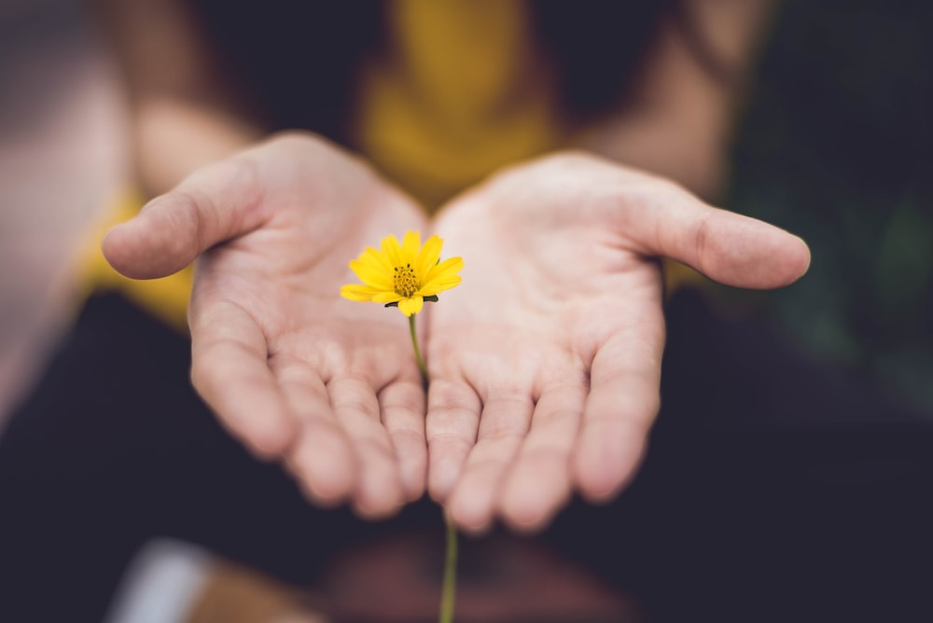

4. Assess their current safety

* + Always respect what the victim survivor wants, however, if there is an immediate risk, you will need to let the victim survivor know that you will have to notify an appropriate service.

**What not to do when responding to a disclosure:**

* + Talk about your own experiences of violence. This takes the attention and focus away from the victim survivor.
  + Pressure the victim survivor to provide you with more details. They may be feeling a range of different and often conflicting emotions which can lead to further distress.
  + Judge the victim survivor’s experience or choices. This can lead to them feeling blamed and unsafe, creating barriers to help seeking behaviour.
  + Make comments that imply there’s something they could have done to avoid what happened. This is victim blaming and can lead to further traumatisation.
  + Talk negatively about the perpetrator. It is important to remain neutral as you may not have all the information required to make an informed assessment.
  + If the disclosure is online, do not leave the disclosure unacknowledged. If you’re unable to respond immediately, let them know when you can.

# Being an active bystander

Being an active bystander means noticing when someone’s behaviour is inappropriate or problematic and choosing a safe strategy to respond. Active bystanders send a message that a perpetrator’s behaviour (e.g., sexist language) is not acceptable and in doing so, promotes a culture of respect.

The National Student Safety Survey (2021) found that one in two university students who witnessed sexual harassment did something about the most recent incident they witnessed. Together, we can increase this number.

**Here are some ways to be an active bystander:**

Indirect intervention

* Do not participate or join conversations that are sexist or discriminatory.
* Physically leave a situation to show that you do not agree with what is going on.
* Shake your head and/or sigh to demonstrate that you do not support the comments made.
* Change the conversation or topic.

Direct intervention

* Name or acknowledge the offence. E.g., “That comment is pretty offensive if you think about it.”
* Challenge the logic. E.g., “What makes you think/say that?”
* Talking privately to the impacted person. Check in to see how they are feeling and provide information around support and report options.
* Talking privately to the person acting inappropriately. E.g., “The joke you made in yesterday’s class was not funny and not okay.”
* Get help from somebody with authority (e.g., teaching staff, Security, Safer Community).

Supports

On campus

**Safer Community**

Safer Community offers advice, support, intervention, and risk

management for students who experience or witness inappropriate, concerning, or threatening behaviours on or off campus. You can get in touch with the team via email or the online reporting form. You can also access relevant contact details via the [Swinburne app](https://www.swinburne.edu.au/life-at-swinburne/student-support-services/study-learning-support/student-systems-hardware-software/mobile-apps/) under the ‘staying safe’ section.

[safercommunity@swin.edu.au](mailto:safercommunity@swin.edu.au)

[swin.edu.au/incident-reporting-form](https://www.swinburne.edu.au/life-at-swinburne/locations/your-safety-at-swinburne/report-an-incident/)

[swin.edu.au/safercommunity](https://www.swinburne.edu.au/life-at-swinburne/locations/your-safety-at-swinburne/#:~:text=You%20can%20report%20an%20incident,students%2C%20staff%20and%20visitors..)

**Swinburne Security**

Contact campus security services for emergencies on campus, after hours assistance or for a security escort. You can access relevant contact details via the [Swinburne app](https://www.swinburne.edu.au/life-at-swinburne/student-support-services/study-learning-support/student-systems-hardware-software/mobile-apps/) under the ‘staying safe’ section.

03 9214 3333 (available 24/7)

**After-Hours Support Line**

The Swinburne after-hours support line is available to help 24 hours a day on weekends and public holidays, and outside business hours on weekdays (before 9am and after 5pm).

Call 1300 854 144 or text 0488 884 145

**International Student Advisory & Support**

Provides personal advice, support, and referral for international students in any adjustments to their life circumstances in Australia.

03 9214 6741 (available 24/7)  
isa@swin.edu.au

**Swinburne Health Service (Counselling and Psychological Services)**

If you are struggling with a personal, emotional, or mental health

difficulty, whether related to your studies or your life away from

university, counselling may help. Register and make an appointment with the counselling services.

03 9214 8483

[swin.edu.au/counselling](https://www.swinburne.edu.au/life-at-swinburne/student-support-services/health-wellbeing/psychology-counselling-services/)

**Independent Advocacy Service**

Swinburne Student Life provides policy advice, support and guidance on academic issues, and advocates for best outcomes in complaints, grievances, appeals and misconduct hearings.

03 9214 5445

[advocacy@swin.edu.au](mailto:advocacy@swin.edu.au)

[swin.edu.au/advocacy](http://www.swin.edu.au/advocacy)

Off campus

**Victoria Police, Sexual Offence and Child Abuse Investigations Team (SOCIT)**

National emergency response and reporting regarding sexual offences and child abuse.

In emergencies call [000](https://www.triplezero.gov.au/) (available 24/7)

[police.vic.gov.au/reporting-sexual-offences-child-abuse](https://www.police.vic.gov.au/reporting-sexual-offences-child-abuse)

**Victoria Sexual Assault Crisis Line**

Confidential, state-wide, after-hours crisis counselling for people who have experienced past and recent sexual assault.

1800 806 292 (available after-hours)

[sacl.com.au](https://www.sacl.com.au/)

**National Sexual Assault and Domestic Violence Service**

24/7 phone and online counselling service for victim survivors of sexual assault, and domestic or family violence.

1800 737 732 (available 24/7)

[1800respect.org.au](http://1800respect.org.au/)

**Eastern Centre Against Sexual Assault (ECASA)**

Free counselling and support service for people who have experienced sexual assault either recently or in the past. The service is also available to non-offending family and friends

03 9870 7310

[ecasa@easternhealth.org.au](mailto:ecasa@easternhealth.org.au)

[easternhealth.org.au/services](http://easternhealth.org.au/services) and search “ECASA”

**Men’s Referral Service (No To Violence)**

Advice and support for men concerned about their anger or violence towards their family. The service also provides help to women or other family members who are experiencing violence or controlling behaviour by men.

1300 766 491 (available 24/7)

[ntvmrs.org.au](http://ntvmrs.org.au/)

**MensLine**

Telephone and online counselling service for men with emotional health and relationship concerns including issues of violence.

1300 789 978 (available 24/7)  
mensline.org.au

 

**Further information**

**Email**  safercommunity@swin.edu.au

**Web** swin.edu.au/safercommunity

**Canvas** [swinburne.instructure.com/enroll/LBX38D](https://swinburne.instructure.com/enroll/LBX38D)

Off campus

**QLife**Peer support and referral for LGBTIQA+ people and their friends, families, and allies in Australia. Phone and webchat are open from 3pm – midnight every day.  
1800 184 527

[qlife.org.au](https://qlife.org.au/)

**Drummond Street Services**Victorian service that provides a variety of counselling service and other options to the LGBTIQA+ community.   
03 9663 6733

[ds.org.au](https://ds.org.au/)

**Women’s Information and Referral Exchange (WIRE)**Victorian service that provides free support, referral, and information on any issue for all Victorian women, non-binary, and gender diverse people.

1300 134 130 [wire.org.au](http://www.wire.org.au)

**Djirra**Provides culturally safe and accessible services to Aboriginal people seeking support in Victoria.

1800 105 303

[djirra.org.au](https://djirra.org.au/)

**13YARN**National 24/7 Aboriginal & Torres Strait Islander crisis support line.

13 92 76 (available 24/7)

[13yarn.org.au](https://www.13yarn.org.au/)

**inTouch**Victorian specialist family violence service that works with women from migrant and refugee backgrounds, their families, and communities.

1800 755 988[intouch.org.au](https://intouch.org.au/)

**National disability abuse and neglect hotline**

A free, independent, and confidential service for reporting abuse and neglect of people with disability.

1800 880 052[jobaccess.gov.au](https://www.jobaccess.gov.au/)and search “hotline”

**Safe Steps**

The Disability and Family Violence Crisis Response Initiative at Safe Steps assists women and children with a disability who are experiencing family violence to access the services and supports they need to stay safe, quickly.

1800 015 188 (available 24/7)  
[safesteps.org.au](https://www.safesteps.org.au/)

Specialist supports

CRICOS 00111D RTO 3059